CS 148 Databases for Web Fall 2015
Andy Green
Burlington Bored Gamers Board
Version 2.0

Table Of Contents
Time Log 3
Software Requirements Specifications 4
Introduction 4
Purpose 4
Definitions, acronyms, and abbreviations 4
Overall Description 4
Story Board 5
Assignment requirements 6
Specific requirements
7

Time Log
Estimated time to complete assignment => |  |  | ___40__ Hours
Date | Time Spent  (in hours) | Description | Author
4/21/15 | 2 | Made Documentation and created skeleton for site | Andy
4/30/15 | 2 | Created Logo and basic style outline | Chris
5/2/15 | 10 each | Re-vamped skeleton, got form to submit, created full style, did round 1 of testing, implemented round 1 results. | Andy/Chris
5/3/15 | 10 | Implemented filtering, troubleshooting | Andy
5/3/15 | 6 | Finalized style, implemented filter colors, round 2 of testing and implementation. | Chris
 | 30 | <=Total Time Spent

Software Requirements Specifications

Introduction

Purpose
The purpose of this document is to describe the requirement specification for the web site “boredgamersboard.com”.
The intended audience for this document is the prospective developers of this site. The goal being that you can give this document to someone and they can make the site without having to ask any questions.
The web site to be created is Bored Gamers Board for the purposes of connecting UVM gamers together to play games together in a twitter like format.

Definitions, acronyms, and abbreviations
HTML – Hypertext markup language – used to define your conent.
PHP – Personal Home Page – language that helps to customize html.
CSS – Cascading Style Sheets – used to define the look of a web site.
W3 Validation – refers to both Html and CSS validation tool provided by the W3c.org. the html validator is located at:
http://validator.w3.org/
with the CSS validator located at:
http://jigsaw.w3.org/css-validator/

Overall Description
The intention of this site is to connect gamers in the Burlington area. The main feature of the site is a request feed on the home page that shows post that people have submitted to the site of what they want to play with people. Each post is laid out with the person’s Name, in game ID, the game they wish to play, the system they are using, a description of what they want to do, and the time and date of the submission.
For the Purposes of release the sites feature will be very bare bones, we are only implementing the Main feature along side with the giveaway and Events page.

Story Board
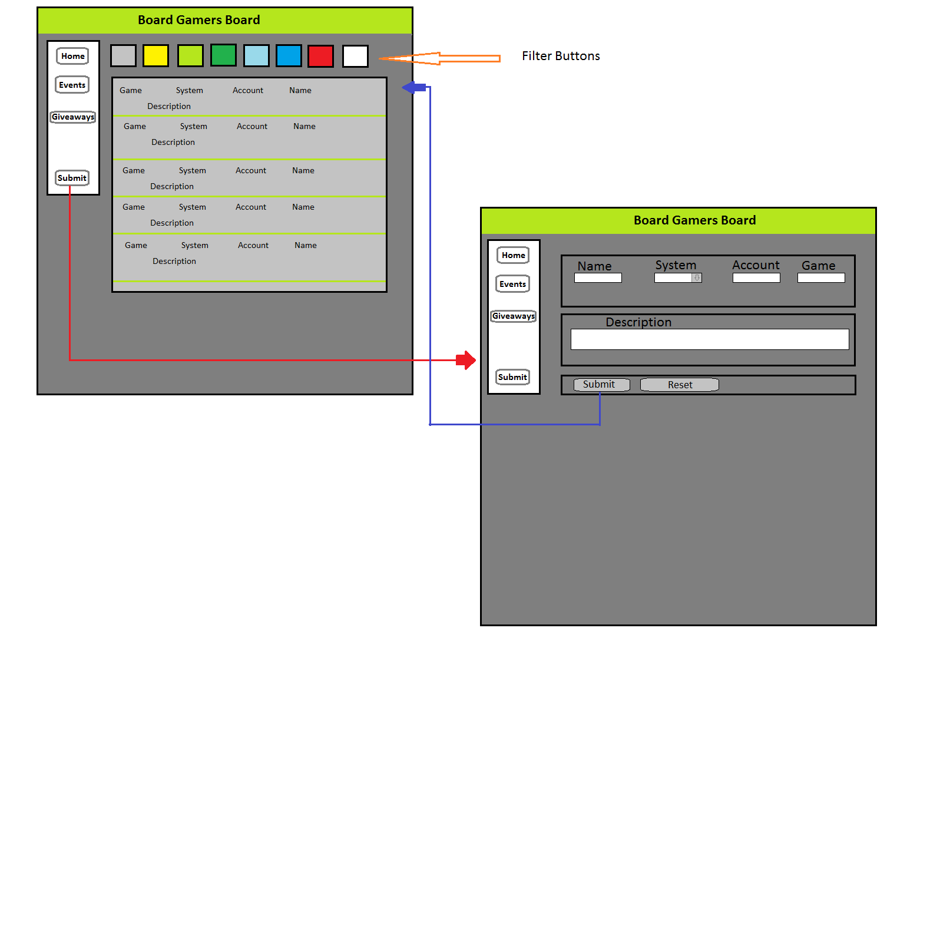

Assignment requirements
- Location – all files will be located in the public folder of your uvm account. The assignment web page and the submit process will detail the exact location. Failure to have your site located in the correct folder by the due dates will result in a zero on the assignment. Be sure to pay attention to the lowercase letters.
- Html Validation – All pages will pass W3C Html validation for html 5.
- CSS Validation – All pages will pass W3C CSS 3.0 validation.
- Meta Information – All pages will contain a proper title tag, Meta tags (author, character set and description).
- CSS – all pages will have a linked style sheet. Start off with my sample from the lectures.
- Navigation – All pages will contain navigation to all other pages on the site using an ordered list. Be sure to enclose the navigation in the correct element.
- Browser compatibility - This site will be checked on Firefox, Safari, Chrome and Internet Explorer.
- Responsive - This site will be checked on: http://quirktools.com/screenfly/

Specific requirements
- Header – include a header.php on each page that contains the head and header for the site
- Nav- include a nav.php that contains the nav for the site on each page
- Footer- include a footer.php that contains all footer code for the site on each page
- Form – At least one form is required, with at least the following. Three textboxes one of which is for the users email, one list box, three check boxes, three radio buttons, field sets/legends where needed, data validation. The form should also email the client the info submitted and save them into a SQL table.
- Feed- Create a feed of submissions that people have submitted that will display on the home page in a list format.
- Filter-Using the feed, selectively display submissions based on game system.
- Background color: Use a textured background image repeated.
- Text color: Various colors for the different filters.

